NAME: PRINCESS HILDA MUNYI
REGISTRATION NUMBER BIT/2025/67192
COURSE: BACHELOR OF SCIENCE IN INFORMATION TECHNOLOGY
UNIT: MOBILE APPLICATION DEVELOPMENT
PROJECT: SMART STATIONERY INVENTORY APP
TOPIC: EVENT HANDLING WEEK 8
FIGURE 1.0: LOGIN SCREENSHOT
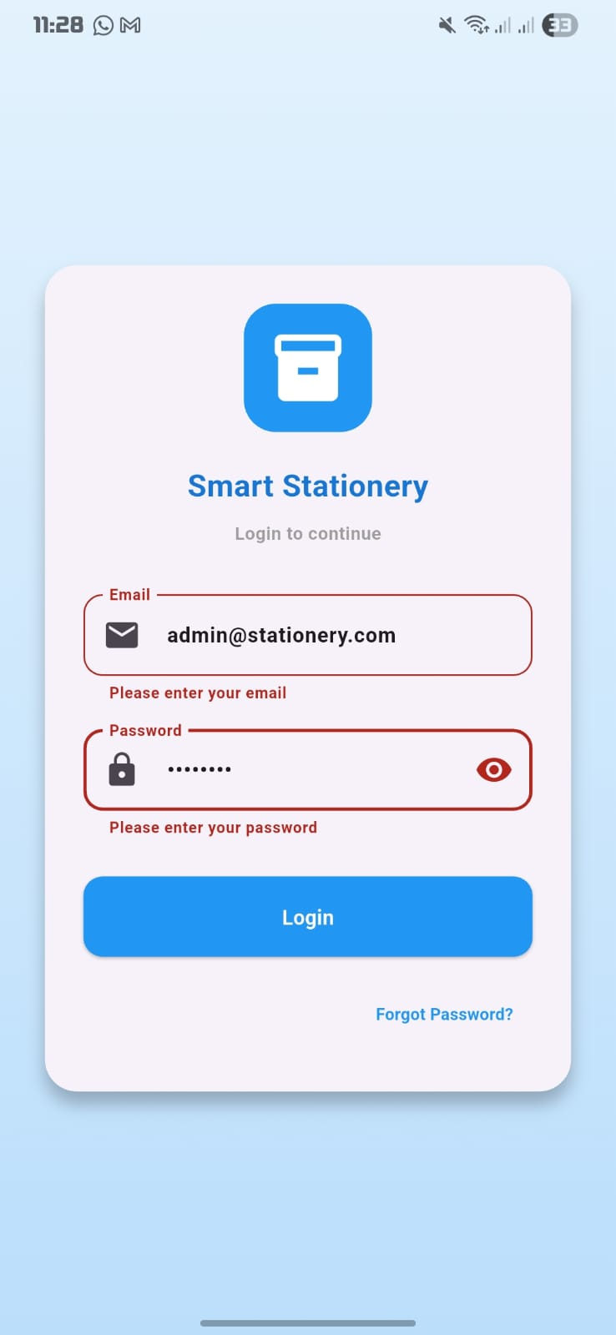

FIGURE1.1: SHOW/HIDE PASSWORD
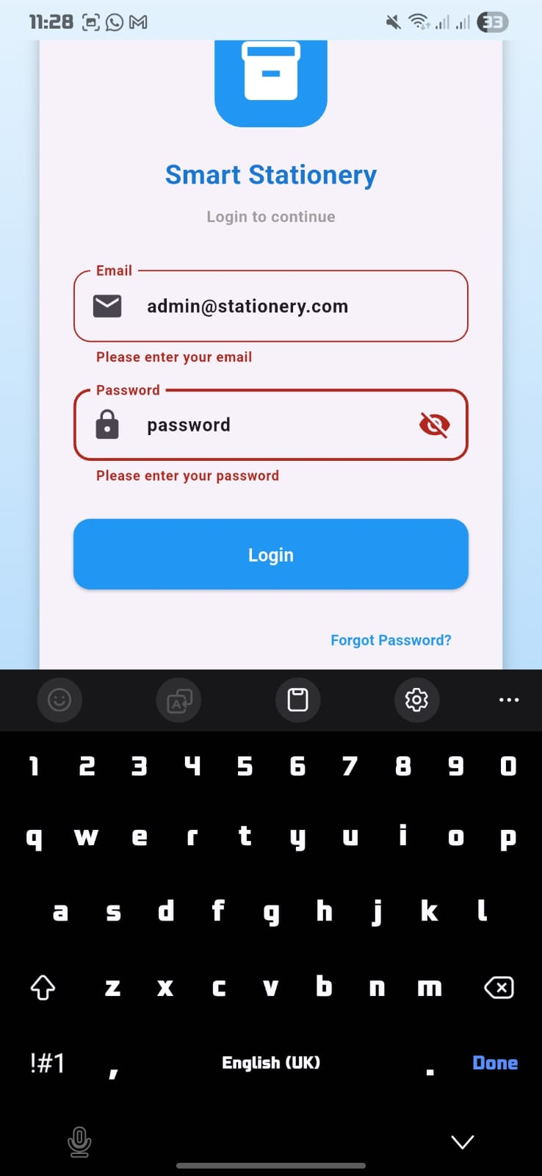
FIGURE1.2: FORGOT PASSWORD
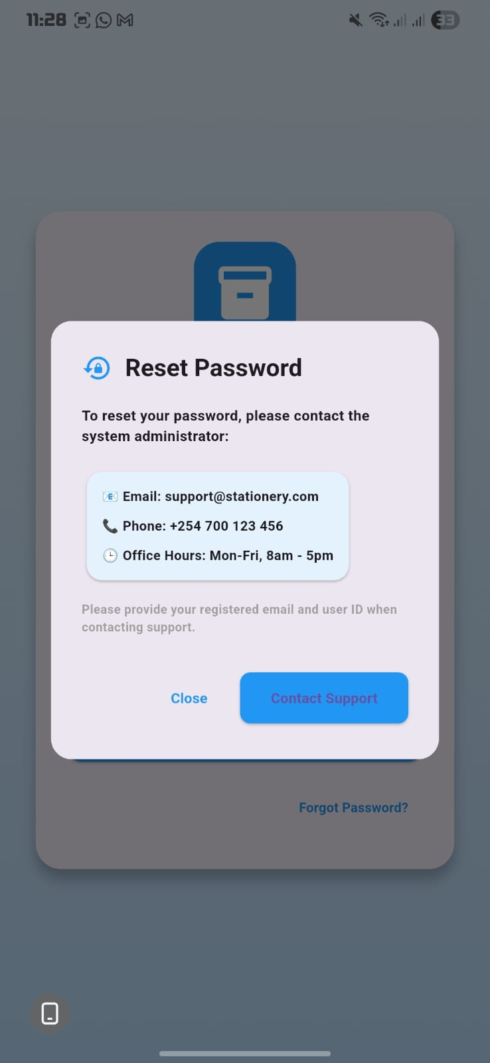
FIGURE1.3: ADD ITEM
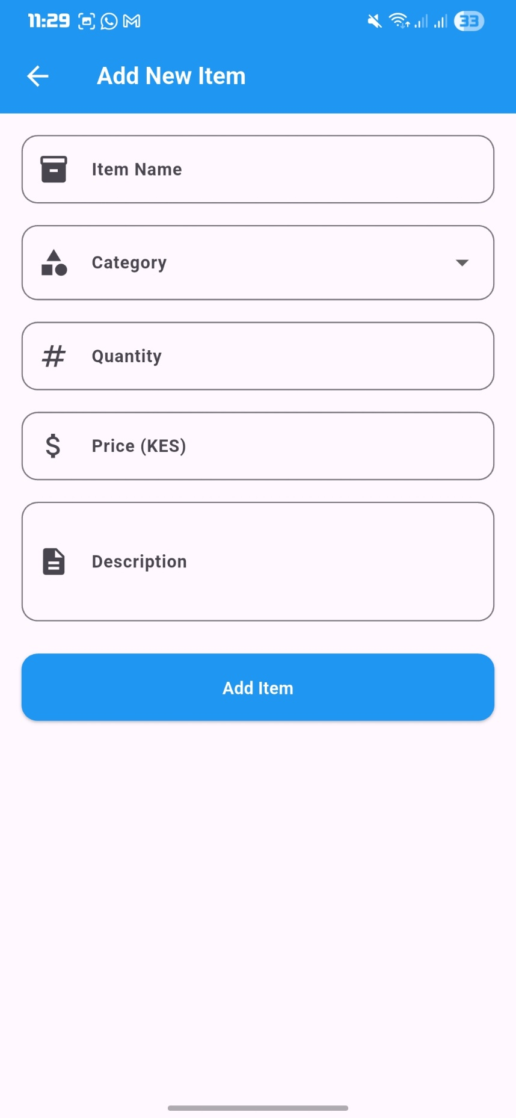
FIGURE1.4: EDIT ITEM
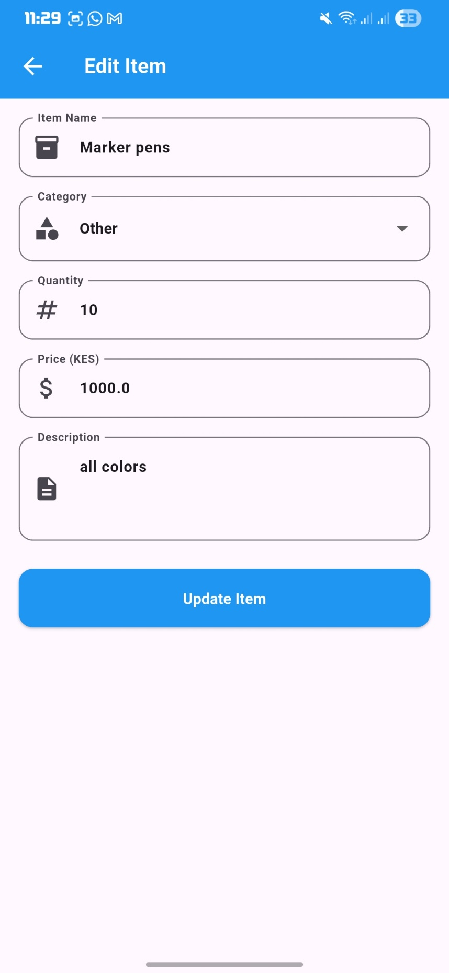
FIGURE1.5: UPDATE ITEM
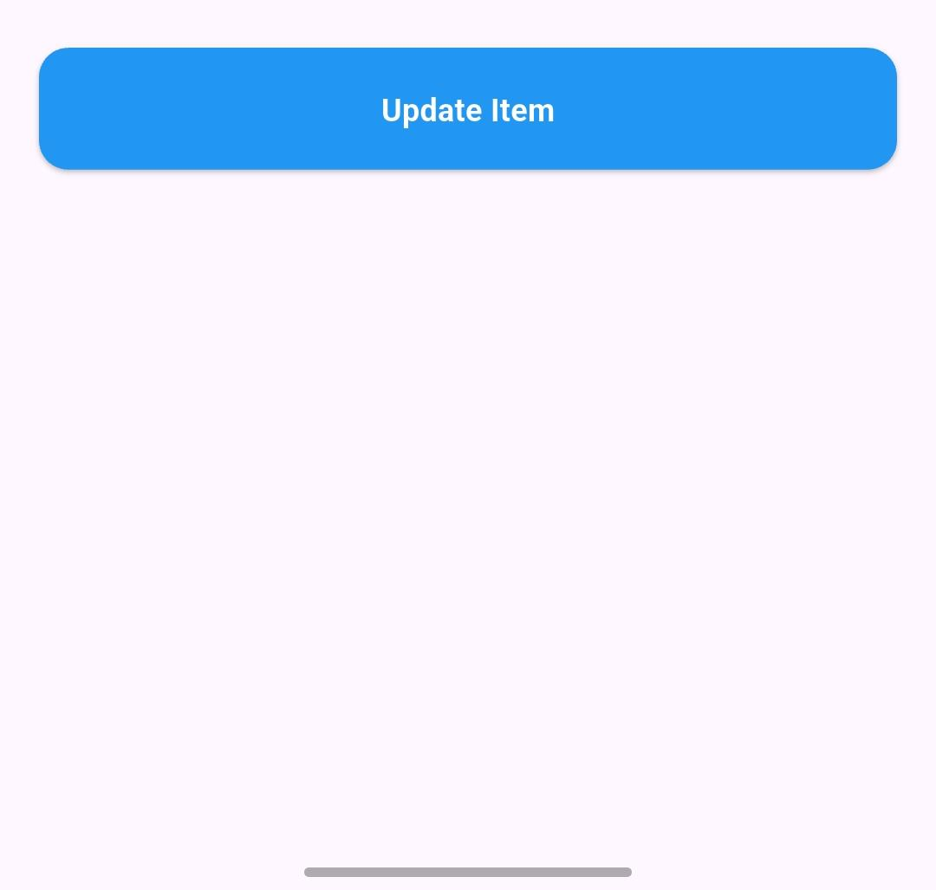
FIGURE1.6: DELETE ITEM
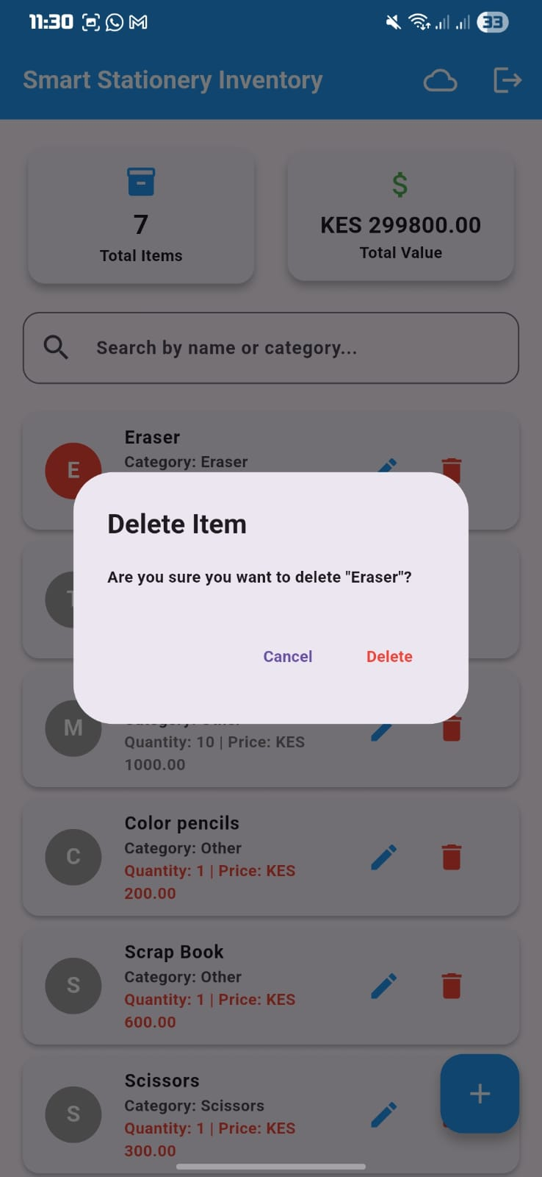

FIGURE1.7 SEARCH
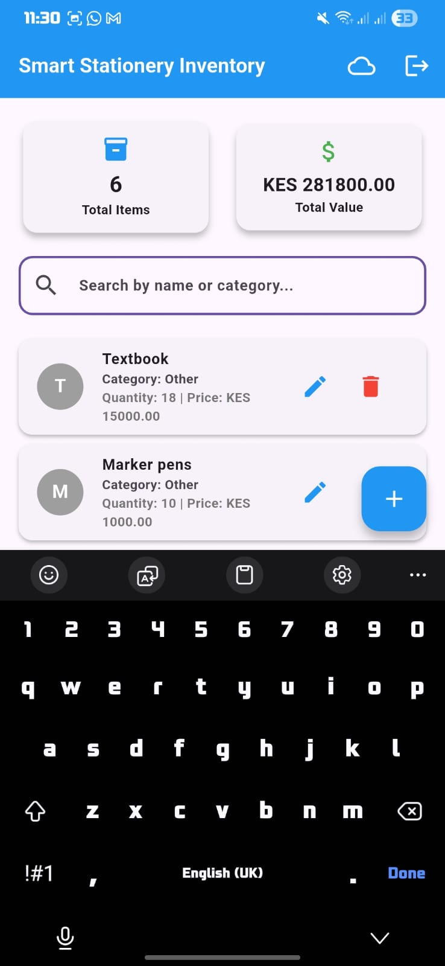
FIGURE 1.8: VIEW ITEM DETAIL
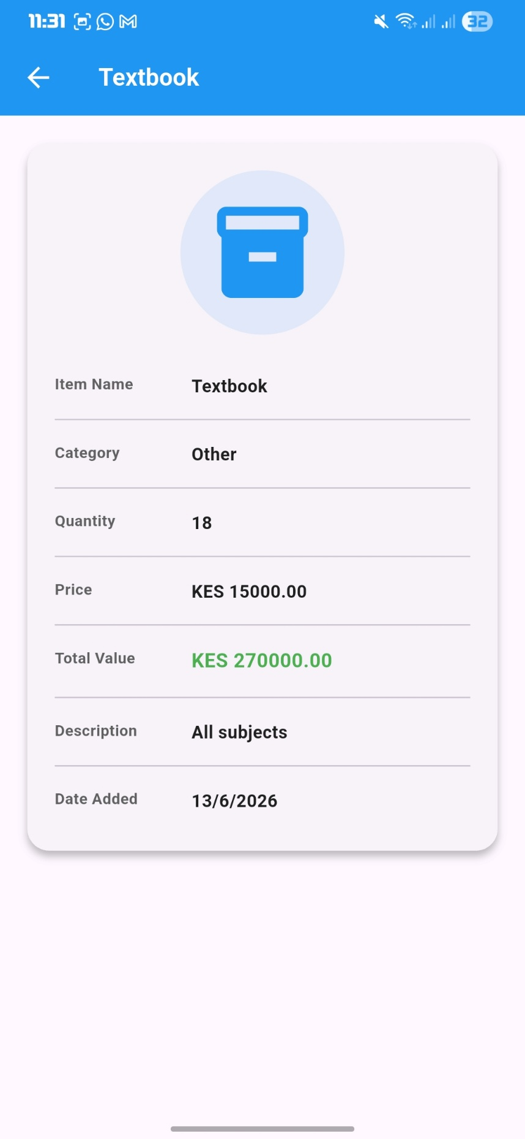
FIGURE1.9: CONFIRM LOGOUT
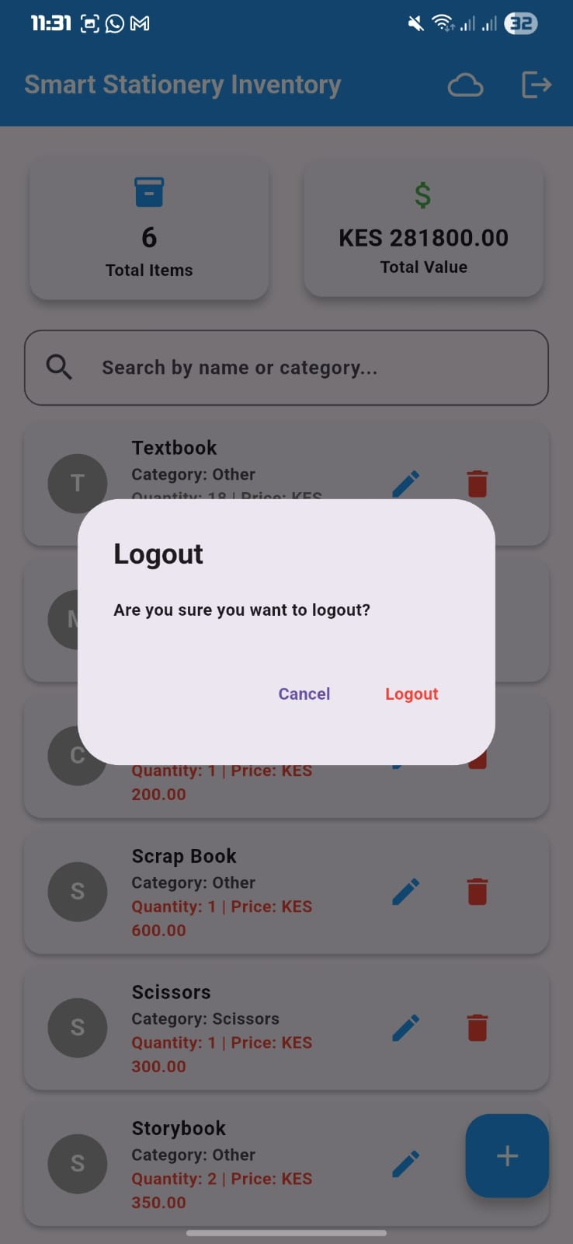
FIGURE 2.0: API EXECUTE
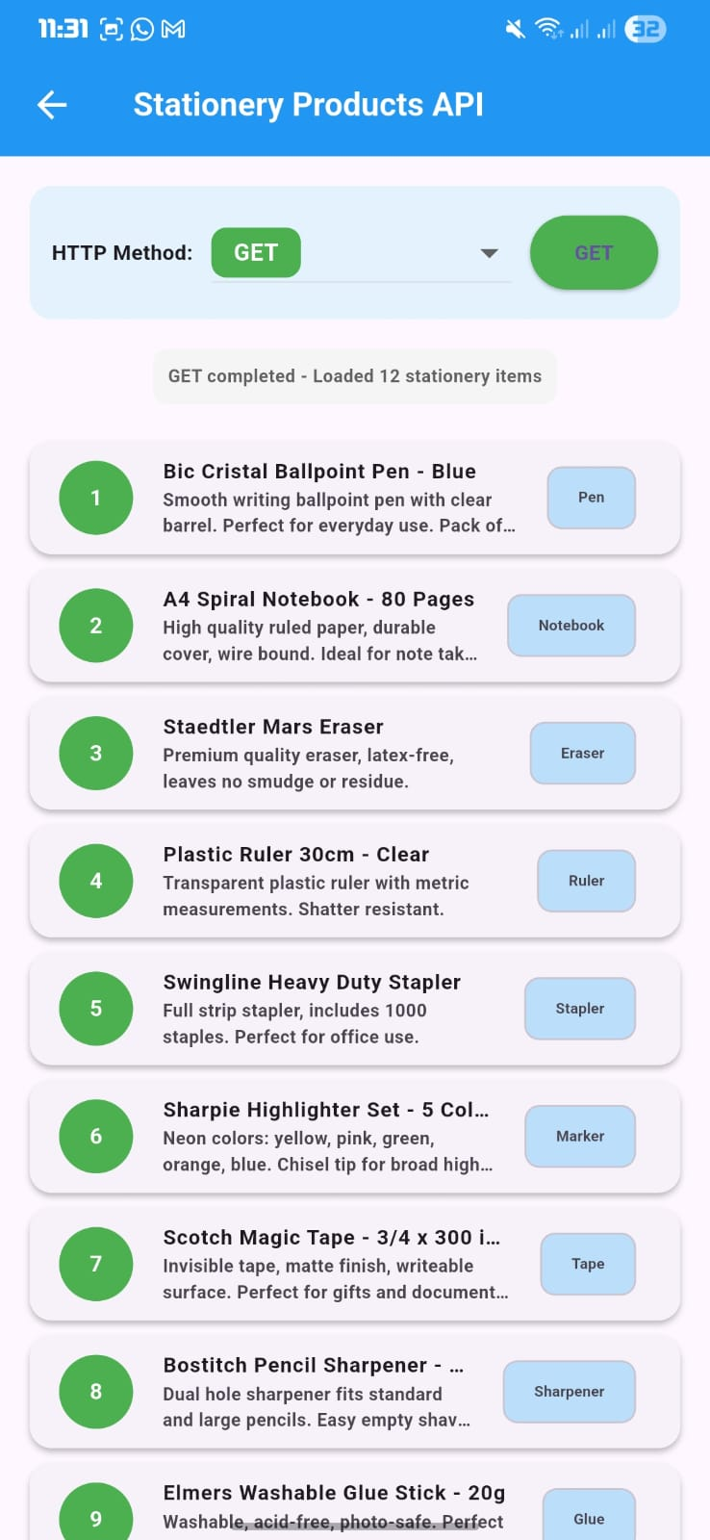
FIGURE 2.1: METHOD SELECT
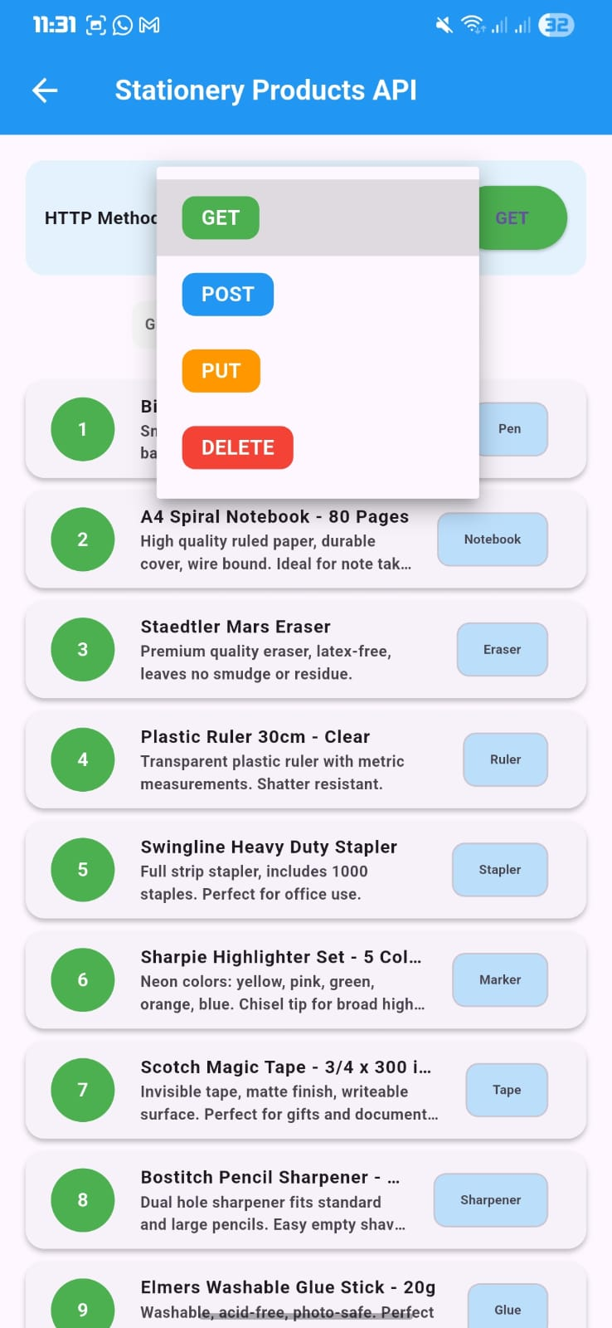
MOBILE APPLICATION DEVELOPMENT LOGBOOK
NAME: PRINCESS HILDA MUNYI
REGISTRATION NUMBER BIT/2025/67192
COURSE: BACHELOR OF SCIENCE IN INFORMATION TECHNOLOGY
UNIT: MOBILE APPLICATION DEVELOPMENT
PROJECT: SMART STATIONERY INVENTORY APP
TOPIC: EVENT HANDLING WEEK 8

Introduction to Event Handling
Objective
To understand event handling concepts in mobile applications and identify all events in the Smart Stationery Inventory app.
Activities Performed
- Studied event handling concepts in Flutter
- Identified all interactive UI components
- Documented event types and their triggers
- Analyzed how events are processed
Outcome
Successfully identified all event types in the application.
Supervisor Signature

Login Button Event Handling
Objective
To implement and test the login button event handler.
Activities Performed
- Implemented `_login ()` function
- Added email and password validation
- Added loading indicator during authentication
- Implemented success and error responses
- Added password visibility toggle event
Outcome
Login event handler works correctly with validation.
Supervisor Signature*
________________________________________

Add Item Event Handling
Objective
To implement add item event handlers.
Activities Performed
- Implemented Floating Action Button click event
- Created form validation events
- Implemented save button event
- Added success and error snack bar events
- Implemented form field change events

Outcome
Add item events work correctly with validation.

Supervisor Signature
________________________________________
Edit and Update Event Handling
Objective
To implement edit and update event handlers.
Activities Performed
- Implemented edit icon click event
- Created pre-filled form for editing
- Implemented update button event
- Added confirmation dialog events
Outcome
Edit and update events work correctly.

Supervisor Signature
_______________________________________
Delete and Confirmation Event Handling
Objective
To implement delete and confirmation dialog events.
Activities Performed
- Implemented delete icon click event
- Created confirmation dialog
- Implemented confirm and cancel dialog events
- Added success snackbar event
Outcome
Delete events work correctly with confirmation.

Supervisor Signature
____________________________________
Search and Filter Event Handling
Objective
To implement search and filter event handlers.
Activities Performed
- Implemented text field change event
- Created search filter function
- Implemented clear search event.
Outcome
Search events work correctly with real-time filtering.

Supervisor Signature
________________________________________

Logout and Navigation Events
Objective
To implement logout and navigation event handlers.
Activities Performed
- Implemented logout icon click event
- Created logout confirmation dialog
Outcome
Logout events work correctly.

Supervisor Signature
________________________________________

API Event Handling
Objective
To implement API request event handlers with loading and error states.
Activities Performed
- Implemented GET request event
- Created loading state events
- Implemented POST, PUT, DELETE events
- Added error handling events
- Implemented HTTP method selection event
Outcome
API events work correctly with loading and error handling.

Supervisor Signature
________________________________________

DECLARATION

I hereby declare that this logbook and the accompanying Smart Stationery Inventory application is my original work.

PRINCESS HILDA MUNYI
BIT/2025/67192

